EXPERIMEMT:7: Create a Virtual Machine with 1 CPU, 2GB RAM and 15GB storage disk using a Type 2 Virtualization Software.

STEP:1: GO TO THE FILE AND CREATE A NEW VIRTUAL MACHINE,KEEP IT IN TYPICAL AND MOVE TO NEXT.

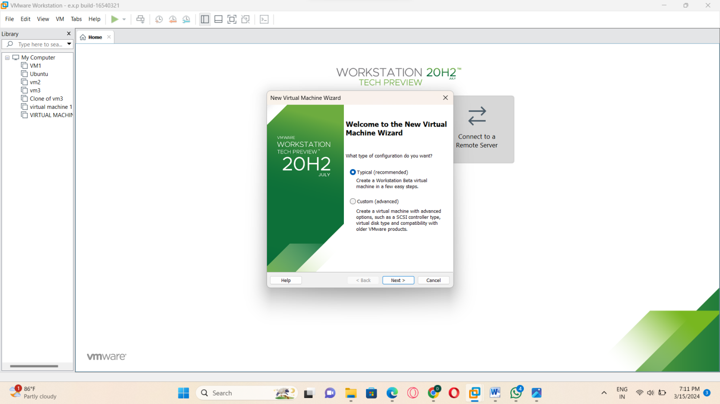

STEP:2:AND NOW SELECT THE GUEST OPERATING INSTALLATION.

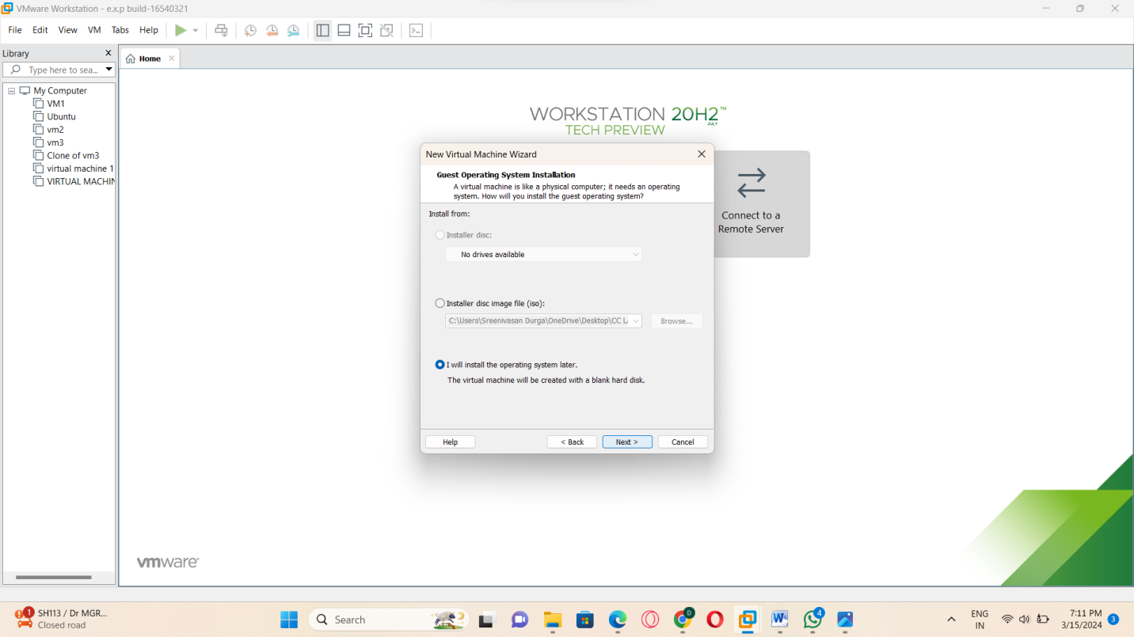

STEP:3:AND THEN SEKLECT THE GUEST OPERATING SYSTEMS

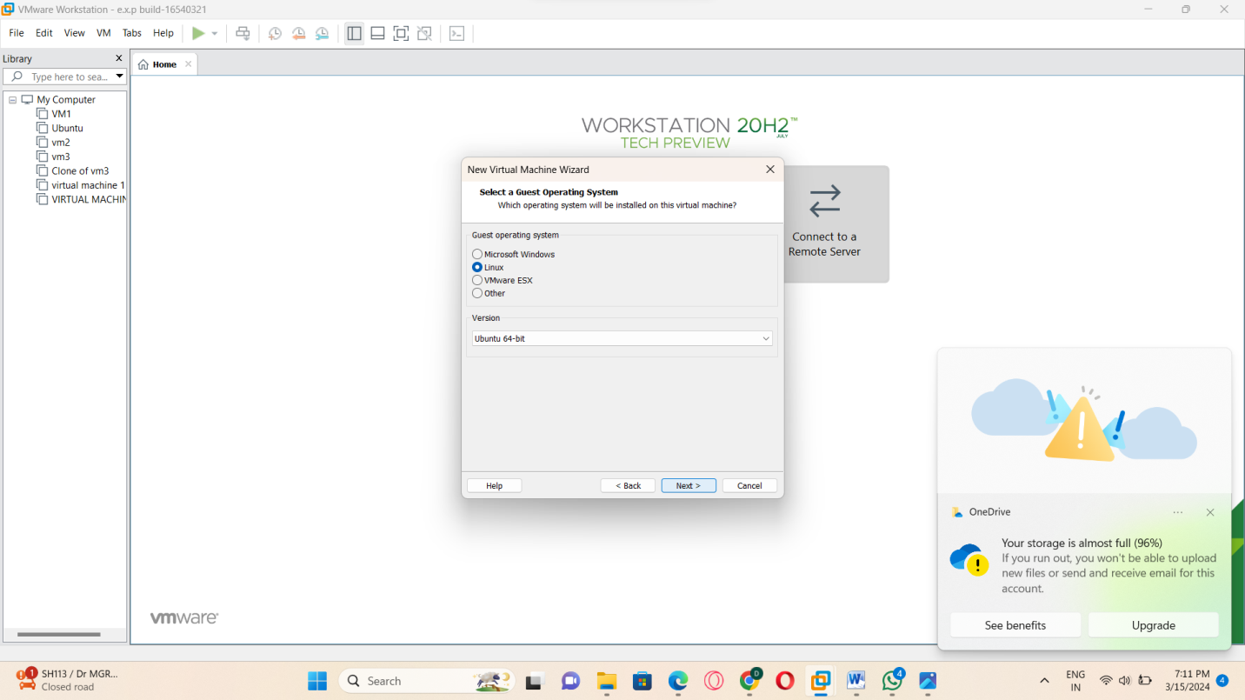

STEP:4:AND THE SAVE IT WITH ANY NAME FOR VIRTUAL MACHINE.

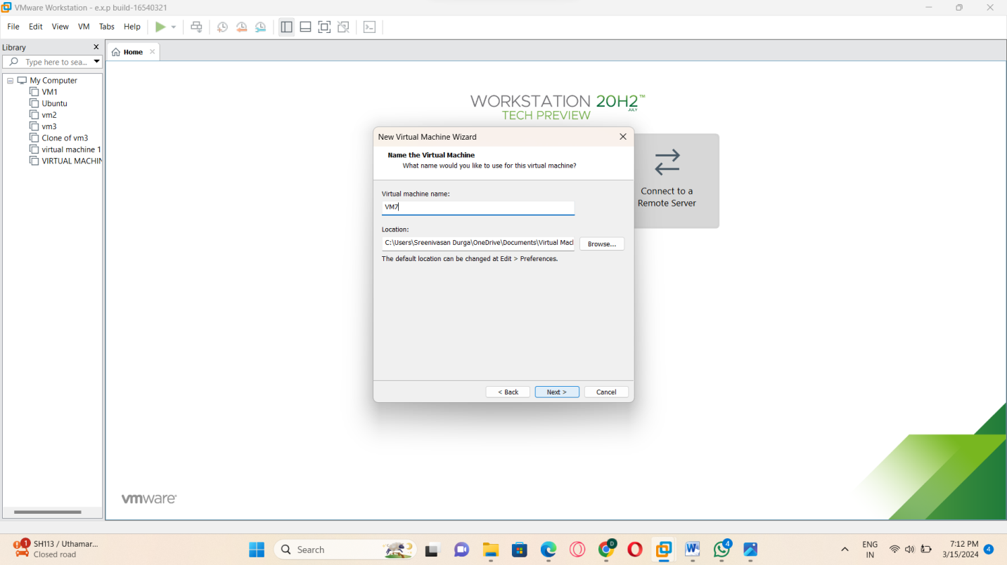

STEP:5: AND THEN SPECIFY THE DISK CAPACITY (15GB).

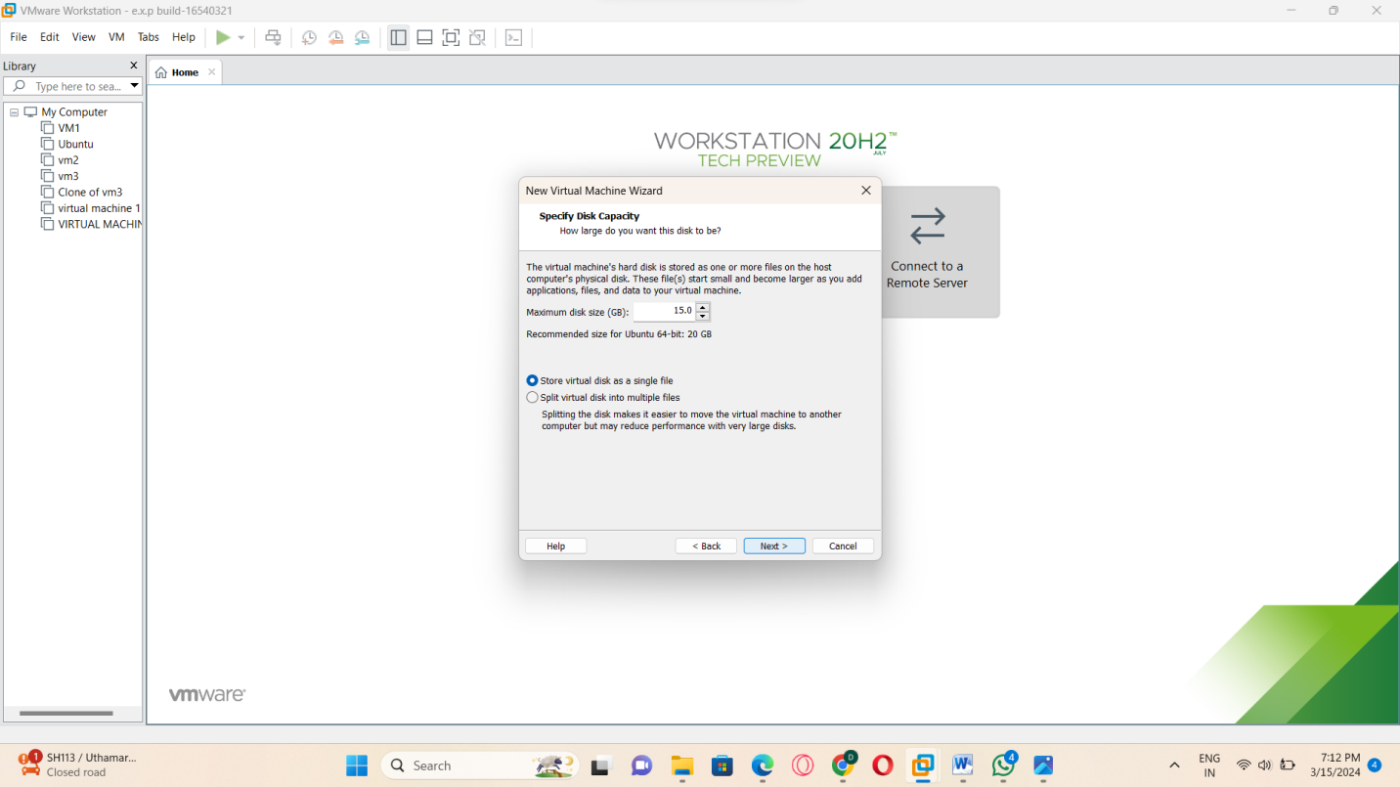

STEP:6: THEN IN THIS PROCESS THE DATA WHAT WE HAVE CREATED WILL BE DONE AND IT ALSO READY TO CREATE THE VIRTUAL MACHINES.

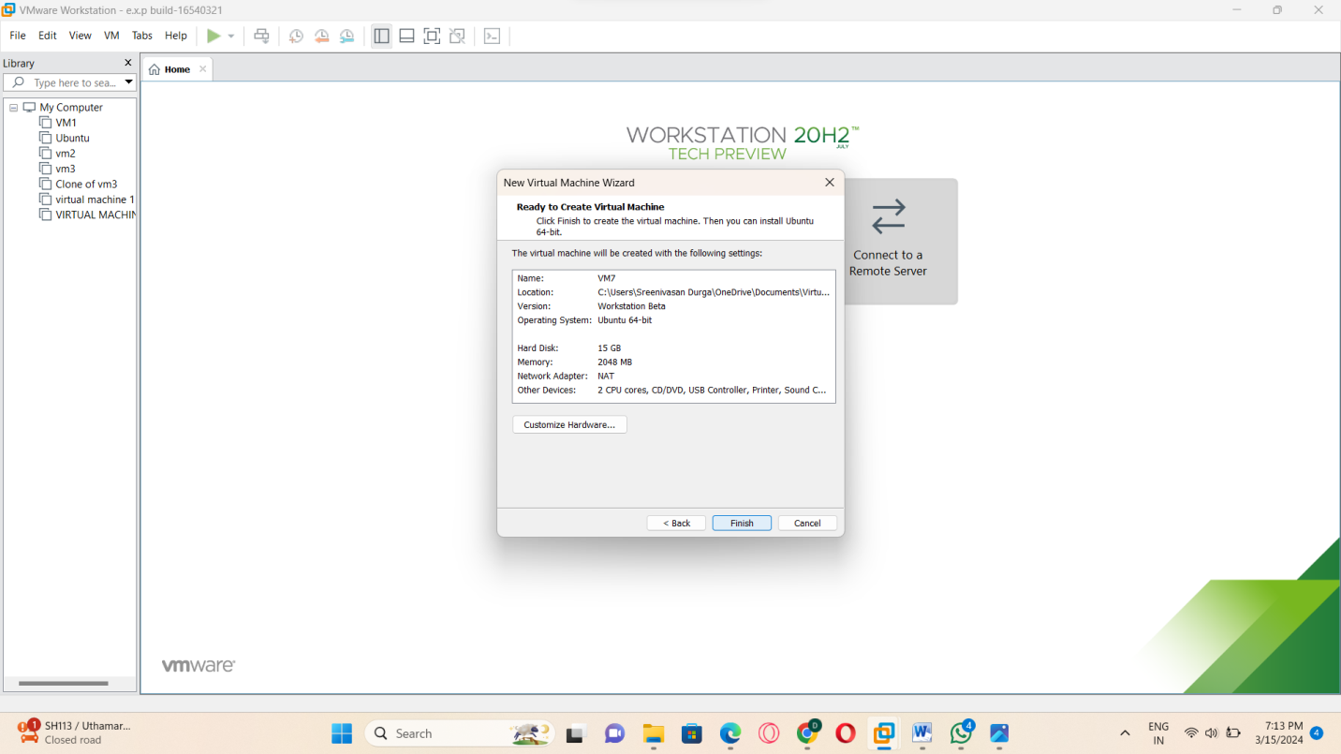

STEP:7: AND THEN CHANGE THE CPU RATE AS 1 IN THIS PROCESS.

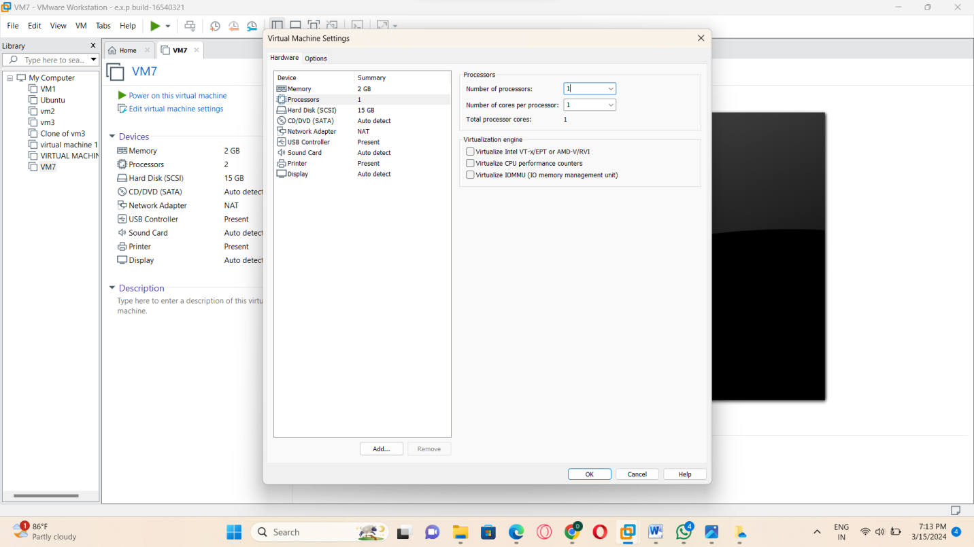

STEP:8: HENCE, CRAETED A NEW VIRTUAL MACHINE USING THE VM-WARE.

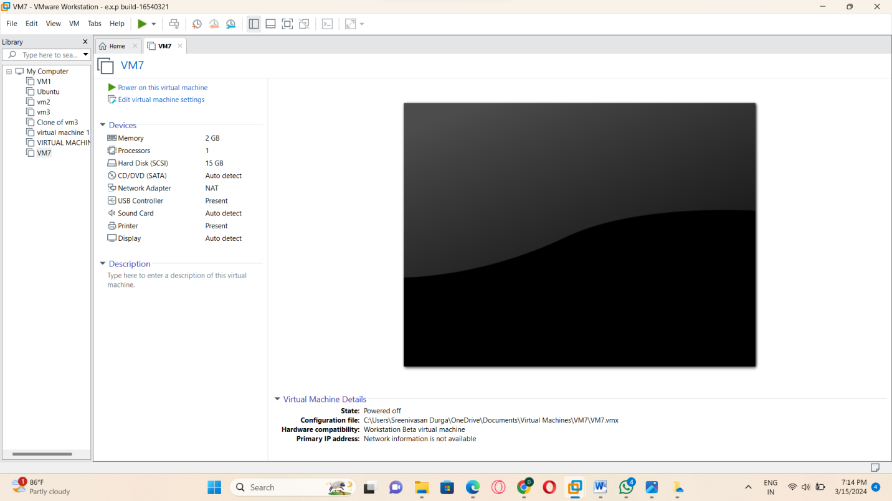

RESULT: THUS,THE PROGRAM IN VM-WARE HAS BEEN EXCEUTED SUCCESSFULLY.